|  |
| --- |
| **C:\Users\faisal\Pictures\NSU_pic_download\n91267046457_2661.jpg**  **CSE 311L(Database Management System)**  **LAB-Week 05 (Part B)**  **))** |

**Manipulating Data**

Topics:

* Copying Rows from Another Table
* Updating Rows in a Table
* Updating Rows Based on Another Table
* Example of Merging Rows

**Copying Rows from Another Table**

INSERT INTO sales\_reps(id, name, salary, commission\_pct)

SELECT employee\_id, last\_name, salary, commission\_pct

FROM emps

WHERE job\_id LIKE ’%REP%’;

**Updating Rows in a Table**

UPDATE emps

SET department\_id = 70

WHERE employee\_id = 113;

**Updating Rows Based on Another Table**

UPDATE copy\_emp

SET department\_id =(SELECT department\_id

FROM emps

WHERE employee\_id = 100)

WHERE job\_id = (SELECT job\_id

FROM emps

WHERE employee\_id = 200);

**Example of Merging Rows**

MERGE INTO copy\_emp c

USING emps e

ON (c.employee\_id = e.employee\_id)

WHEN MATCHED THEN

UPDATE SET

c.first\_name = e.first\_name,

c.last\_name = e.last\_name,

c.email = e.email,

c.phone\_number = e.phone\_number,

c.hire\_date = e.hire\_date,

c.job\_id = e.job\_id,

c.salary = e.salary,

c.commission\_pct = e.commission\_pct,

c.manager\_id = e.manager\_id,

c.department\_id = e.department\_id

WHEN NOT MATCHED THEN

INSERT VALUES(e.employee\_id, e.first\_name, e.last\_name,

e.email, e.phone\_number, e.hire\_date, e.job\_id,

e.salary, e.commission\_pct, e.manager\_id,

e.department\_id);

|  |
| --- |
| **C:\Users\faisal\Pictures\NSU_pic_download\n91267046457_2661.jpg**  **CSE 311L(Database Management System)**  **LAB-Week 05 (Part C)** |

**Managing Tables**

Topics:

* The ALTER TABLE Statement
* Adding a Column
* Modifying a Column
* Dropping a Column
* Changing the Name of an Object
* Truncating a Table
* Add PRIMARY KEY/ FOREIGN KEY constraints
* CREATE VIEW

**The ALTER TABLE Statement**

Use the ALTER TABLE statement to:

* Add a new column
* Modify an existing column
* Define a default value for the new column
* Drop a column

**Adding a Column**

ALTER TABLE dept80

ADD (job\_id VARCHAR2(9));

**Modifying a Column**

ALTER TABLE dept80

MODIFY (last\_name VARCHAR2(30));

**Dropping a Column**

ALTER TABLE dept80

DROP COLUMN job\_id;

**Dropping a Table**

DROP TABLE dept80;

**Changing the Name of an Object**

RENAME dept TO detail\_dept;

**Truncating a Table**

TRUNCATE TABLE detail\_dept**;**

**Add PRIMARY KEY/ FOREIGN KEY constraints**

ALTER TABLE emps

ADD CONSTRAINT emp\_manager\_fk

FOREIGN KEY(manager\_id)

REFERENCES emps(employee\_id);

**Creating a View**

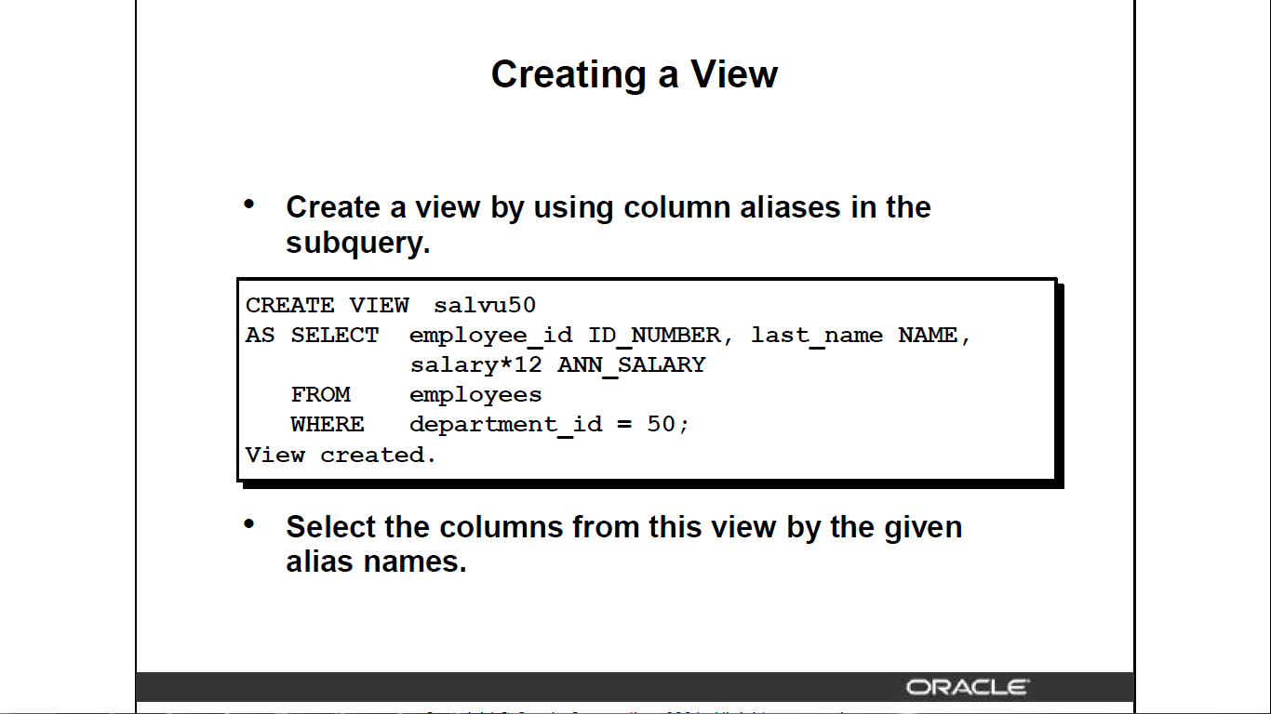

**Homework:**

Create the EMP table based on the following table instance chart..



a. Modify the EMP table to allow for longer employee last names. Confirm your modification.

b. Create the EMPLOYEES2 table based on the structure of the EMPLOYEES table. Include only the EMPLOYEE\_ID, FIRST\_NAME, LAST\_NAME, SALARY, and DEPARTMENT\_ID

columns. Name the columns in your new table ID, FIRST\_NAME, LAST\_NAME, SALARY ,

and DEPT\_ID, respectively.

c. Drop the EMP table.

d. Rename the EMPLOYEES2 table as EMP.

e. Drop the FIRST\_NAME column from the EMP table. Confirm your modification by checking

the description of the table.